NAME: S.PRATIBA
DATE:07.10.25 ROLL No.:241901080

EXERCISE 14
STUDY OF DIFFERENT TYPES OF NETWORK CABLES AND CRIMPING OF CABLE
WITH RJ45 CONNECTOR

AIM:
To study different types of network cables used in computer networks and to understand the process of crimping an RJ45 connector onto a cable for creating reliable physical connections between network devices.
ALGORITHM:
Identifying Different Network Cable Types:
- Visually examine each cable to identify the type (twisted pair, coaxial, or fiber optic).
- Check cable jackets for markings (Cat5e, Cat6, Cat6a).
- For twisted pair cables, unstrip a small section to observe the four color-coded wire pairs.
- Use a cable tester to verify signal transmission quality of each cable type.
- Document bandwidth, speed, and typical applications of each cable.
RJ45 Connector Wiring Standards:
RJ45 Connector Overview:
- An RJ45 connector is an 8-pin (8P8C) modular connector that terminates Ethernet cables and connects network devices like computers, routers, and switches.
- It provides a physical interface for secure, high-speed data transmission in LANs.
Steps to Crimp an RJ45 Connector (Theoretical):
- Strip approximately 1 inch of the cable jacket using a wire stripper without damaging the inner wires.
- Untwist the four colour-coded wire pairs completely.
- Arrange the eight wires in the correct order according to either T568A or T568B standard.
- Trim the wires evenly to ensure neat insertion into the connector.
- Insert each wire fully into its corresponding pin slot in the RJ45 connector (verify wires reach the front).
- Place the connector in a crimping tool and apply firm, even pressure until the contacts secure all wires.
- Test the completed cable using a network cable tester to verify continuity and proper pin mapping.

STUDY OF CABLES:
CABLE  TYPE | PROS | CONS | USAGE | BANDWIDTH | SPEED | IMAGE
Cat5  (Category5) | - Low cost  - Easy to install  -Widely used | Lower speeds- Shorter  maximum  distance (100  meters) | Home  networks- Small  office setups | 100 Mbps | 10/100  Mbps (Fast  Ethernet) | 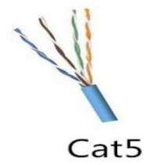
Cat5e  (Category5e) | Enhanced  version of Cat5-  Reduced  crosstalk- More  reliable | - Limited to  100 meters-  Lower speeds  than newer  cables | - Ethernet  Connections-  Home/office  networks | 1 Gbps | 1 Gbps  (Gigabit  Ethernet) | 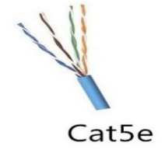
Cat6  (Category6) | - Higher  bandwidth than  Cat5e- Reduced  crosstalk- More  reliable | - More  expensive than  Cat5e- Stiff  and difficult to  work with | - High-speed  Networking -  Large office  buildings | 10 Gbps (up to 55 meters) | 1-10 Gbps  (Gigabit  Ethernet / 10  Gigabit  Ethernet) | 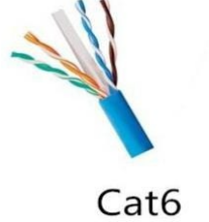
Cat6a  (Category6a) | Supports  higher  bandwidth  Longer  maximum  distance | -Expensive-  Bulky and hard  to install | - Data centres-  High-performance networking | 10 Gbps (up  to 100  meters) | 10 Gbps (10  Gigabit  Ethernet) | 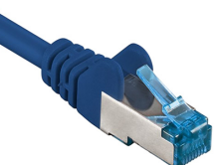
Cat7  (Category7) | - Shielded for  high noise  resistance-  High-speed  performance | -Expensive-  Thick, less  flexible cables | - Data centres-  High-speed  environments | 10 Gbps (up  to 100  meters) | 10 Gbps (10  Gigabit  Ethernet) | 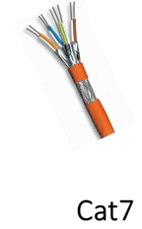
Cat8  (Category8) | - Highest speed &  performance-  Supports  high-frequency  signals | Expensive-  Shorter range-  Heavy and  rigid | - Data centres-  Server rooms-  High-performance applications | 25-40 Gbps  (up to 30  meters) | 25-40 Gbps  (High-Speed  Data Centers) | 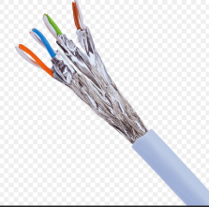
Coaxial  Cable | - Durable- Less  susceptible to  electro-  magnetic  interference | - Low  bandwidth  compared to  twisted pair  cables | - Cable TV-  Broadband  internet  connections | 10 Mbps to  10 Gbps | 10 Mbps to  10 Gbps  (depending  on use) | 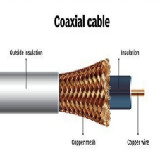
Fiber  Optic | -Extremely  high bandwidth  Very long  Distance-  Immune to EMI | Expensive-  Fragile-  Requires  specialized  installation | -Long-distance  Networking-  High-speed data  transfer | 10 Gbps to  100 Gbps (or  higher) | 10 Gbps to  100 Gbps  (and  beyond) | 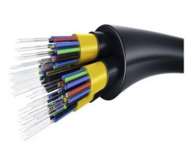
Twisted Pair  (Unshielded) | -Cost-effective-  Light weight-  Easy to install | - Prone to  interference  without  shielding | - Telephone  lines- Home and  office  networking | 100 Mbps | 10/100  Mbps (Fast  Ethernet) | 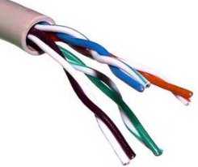
Twisted Pair  (Shielded) | - Higher  resistance to  interference-  Better data  integrity | - More  Expensive-  Less flexible  and harder to  install | - Industrial  settings- Areas  with high  interference | 100 Mbps | 10/100  Mbps (Fast  Ethernet) | 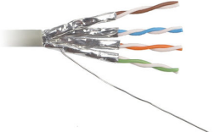

RESULT:
The experiment helped identify various network cables and demonstrated how to crimp RJ45 connectors correctly. This ensured secure connections for reliable data communication in LANs. Practical understanding of cable types and crimping standards was gained.

